**Final Check Sprint 2:** GotoGro-MRM

**Team Details**

|  |  |
| --- | --- |
| **Team Name:** | MSP 14 |
| **Tutorial:** | Tue 2:30 ATC325 |
| **Tutor:** | Dr Kaberi Naznin |

|  |  |
| --- | --- |
| **Members:** | |
| Dylan Jarvis | 102093138 |
| Rabya Tayal | 103144215 |
| Simon Tran | 103602807 |
| Thomas Babicka | 103059885 |
| Cody Cronin-Sporys | 103610020 |
| Nicholas Dyt | 101624265 |

**Trello Days 6-10**

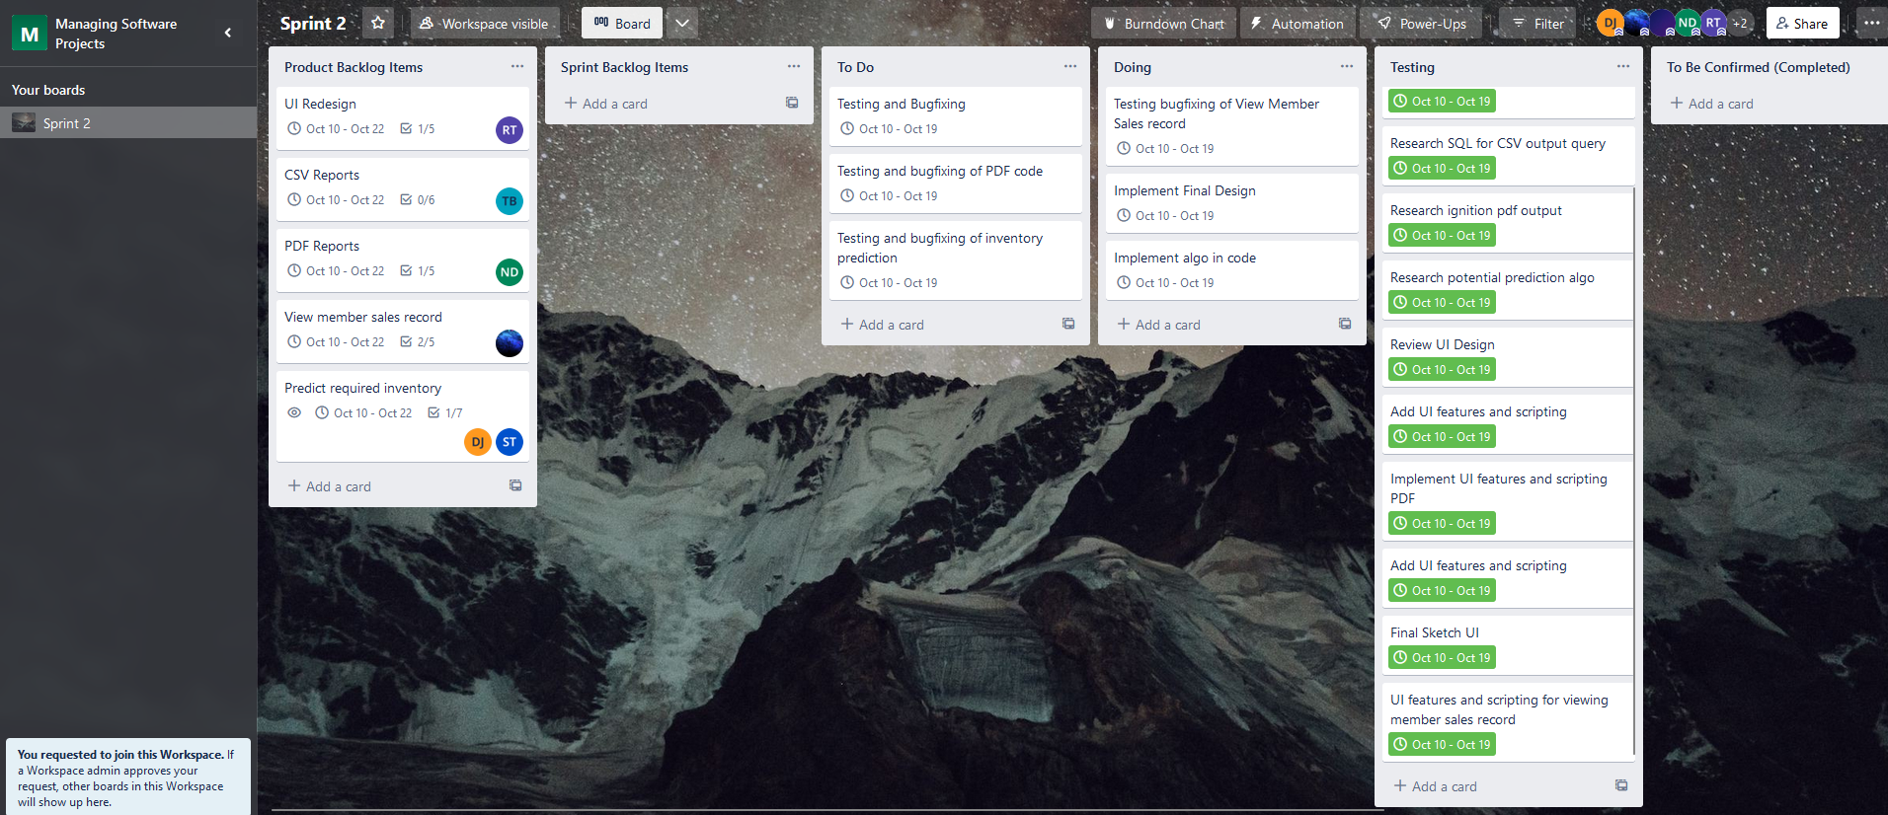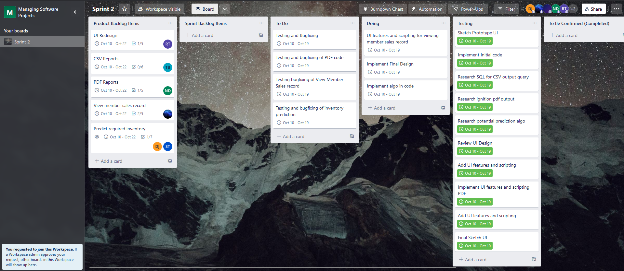There is some overlap with the master document outlining progress, however we were consistent in updating the Trello board to capture ongoing progress.

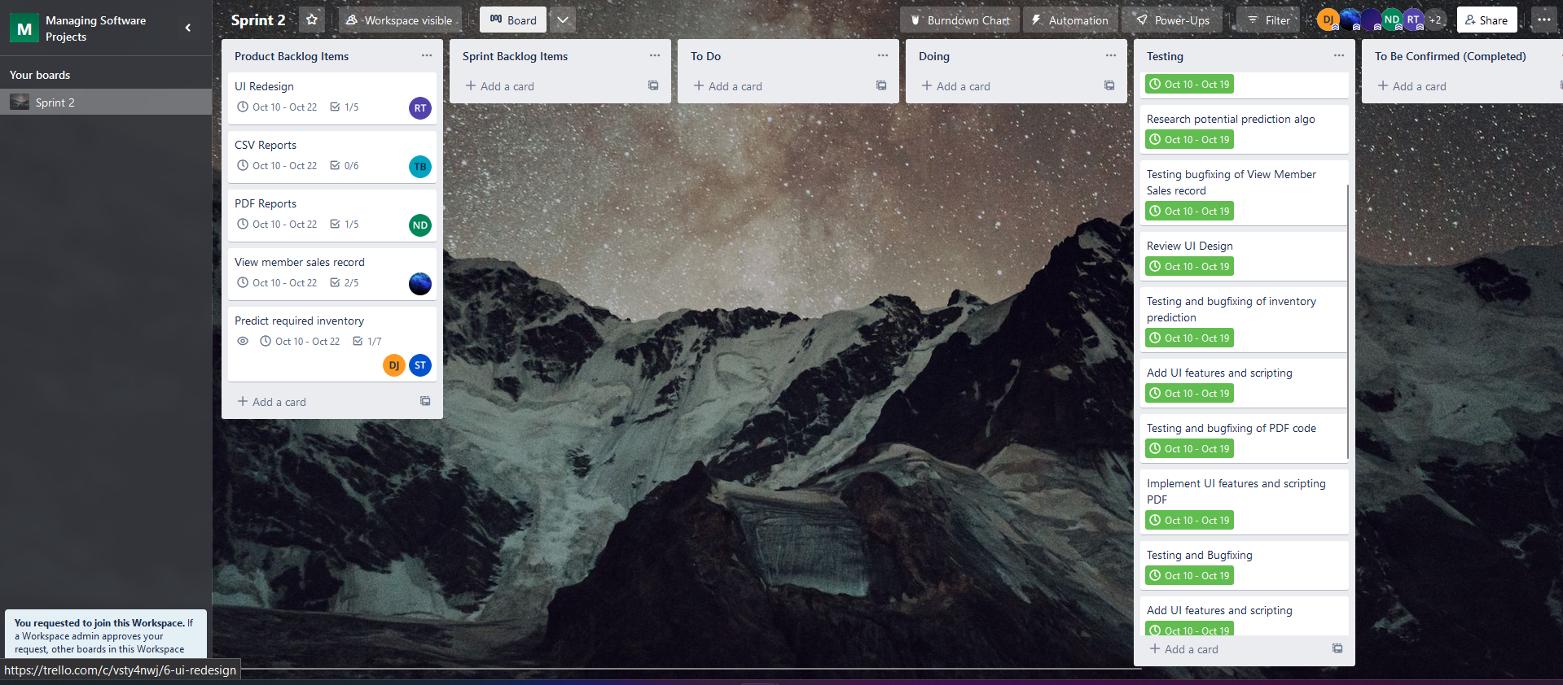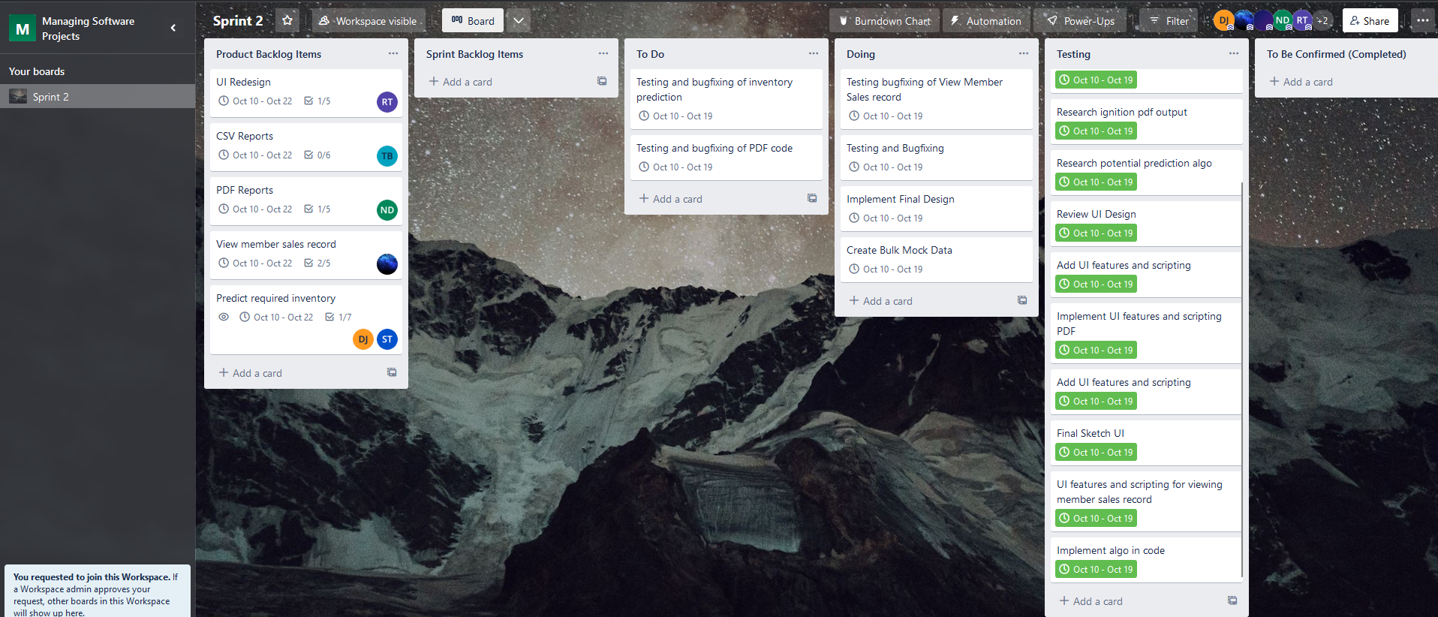

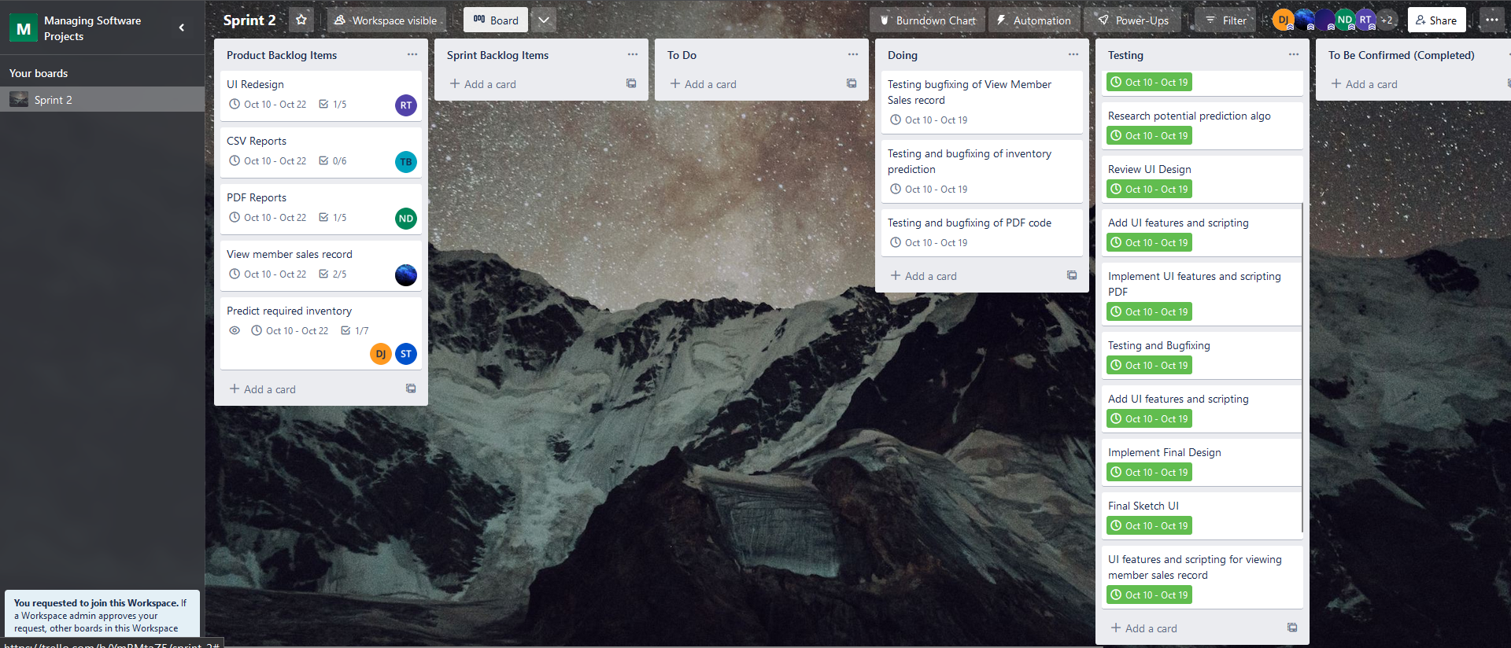

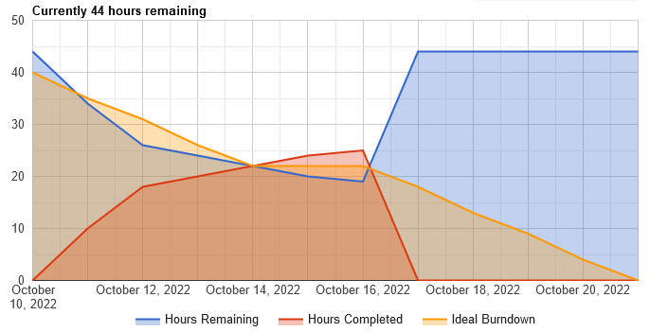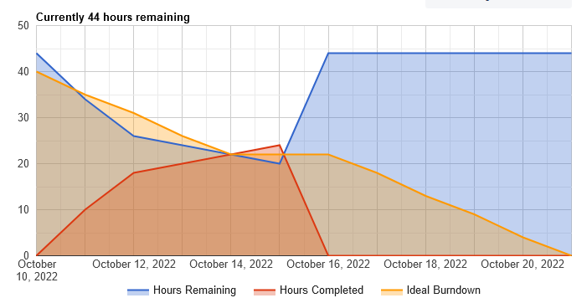**Burndown Chart Days 6-10**

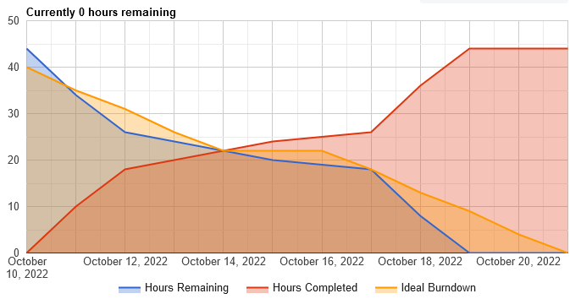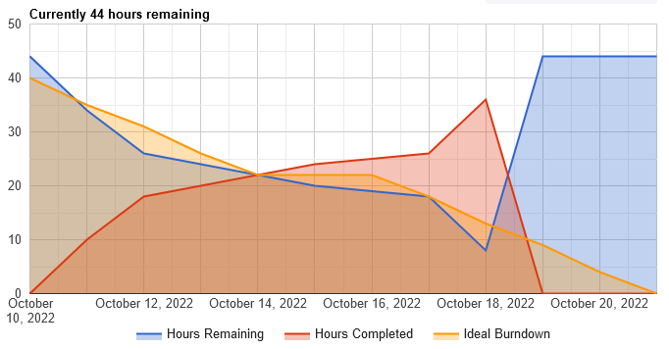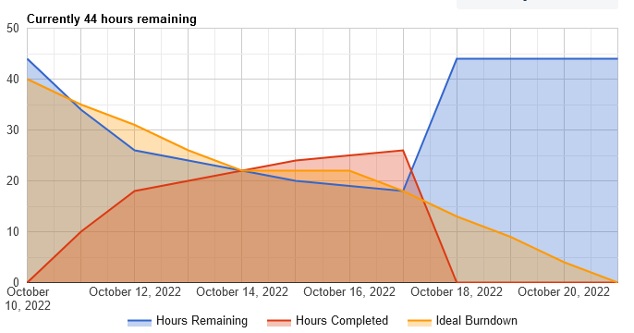

As can be seen from the burndown charts, progress was slow for the first few days of the second half but increased dramatically on the second last day. Other commitments got in the way; however we planned the time well so that we could still achieve the goals in the sprint.

**Group Meeting Notes**

The group meetings were conducted over discord and involved basically checking in with each member and their given tasks to discuss if they had completed it, needed more time, or needed more help. The image below summarises the content discussed:

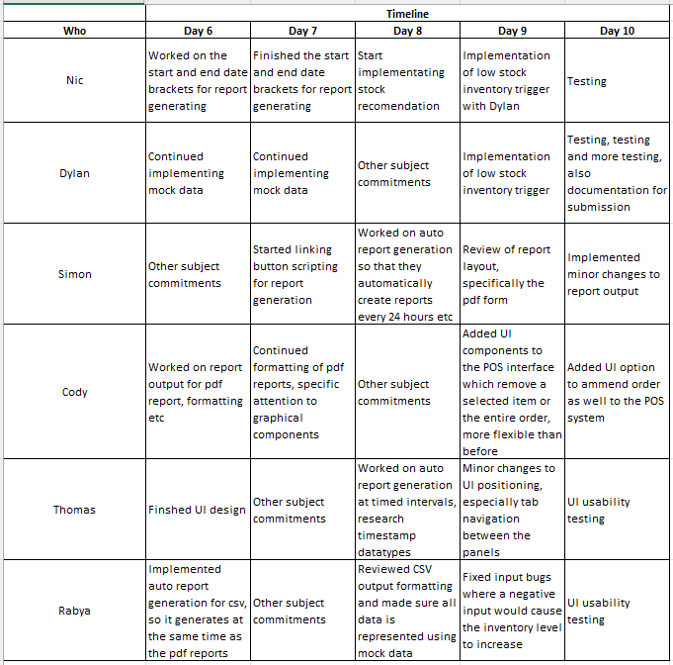

**Github Repository Days 6-10**